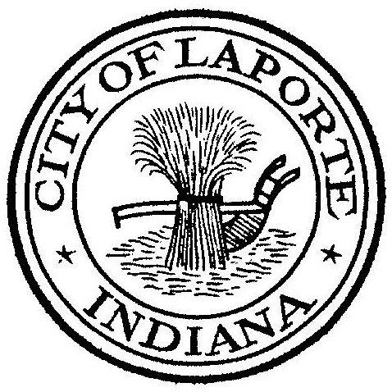
Board of Public Works and Safety
Jessica Romine, Member Tom Dermody, Mayor Mark Kosior, Member
City Hall 801 Michigan Ave., La Porte, IN 46350
Tuesday, May 16, 2023
9:00 AM
AGENDA
- Call To Order
- Pledge Of Allegiance
- Approval Of Minutes
- Public Comment: In Person and via Facebook Live
- Clerk-Treasurer: Claims Approval
- Department Head Reports
- New Business:
-Ticket Appeals: #69134 and #ORDN-23-341
-Beth West: TransPorte Scheduling Policy Revision
-Mark Schreiber: MOU w/Northern Baseball League
Contract for 4th of July Fireworks
-Mary Ann Richards: Quotes Opening CDBG Homeowner Repair Program:
Electrical Repairs
Lead Hazard Reduction at 321 Niles
-Jerry Jackson: Phosphorus Pay Request #13
Letters and Numbers Pay Request #1: Storm/Sewer and Water
Basement Backup Grant:r
-Andy Snyder: Contract for Fire Apparatus Purchase
-Nick Minich: Outdoor Seating Application Hotspot Café
Approval of the Preliminary and Final Plats: Zayo Subdivision
8) Unfinished Business:
9) Other Business: Next regularly scheduled meeting: Tuesday, June 6, 2023 at 9a
10) Adjourn

Tabled May 3, 2023 WM Contract

